Domayne’s Metal Hand Cupboard

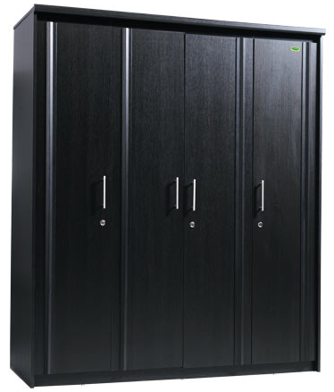

|  |
| --- |
| **DESCRIPTION** |
| Domayne’s dream designing has introduced an extra wide multi storage cupboard with four functional doors. The cupboard has a nice feel with smooth surface and the metallic black color absorbs heat to keep everything smooth inside. It will give your house a complete different look and a door with multi space stores long and wide valuables that easy. |

|  |  |  |
| --- | --- | --- |
| **Price** | **1000$** | |
| **Dimensions** | **H** x **W** x **L** | **77in x 25in x 52in** |
| **Features** | **Metallic paint protects the wood from fire and water and absorbs radiation.** | |
| **Finished** | **Metallic Shine** | |
| **Available in** | **Black Only** | |